Heart Failure Prediction Using Machine Learning Models
ADITYA JHA
23FE10CSE00767
CSE CORE

Abstract
Cardiovascular disease remains the leading cause of mortality worldwide, making early and accurate prediction of heart failure a critical challenge in clinical medicine. This study presents a machine learning-based framework for classifying patients at risk of heart disease using the Heart Failure Prediction Dataset sourced from Kaggle, comprising 918 patient records and 12 clinically significant features. Two classification algorithms are rigorously evaluated: Logistic Regression as a robust statistical baseline and Random Forest Classifier as an advanced ensemble approach. The methodology encompasses comprehensive data preprocessing—including handling of zero-valued cholesterol entries, categorical encoding, and feature normalization—followed by stratified train-test splitting to preserve class distribution. Experimental results demonstrate that ensemble-based methods outperform linear classifiers on this domain. Random Forest achieved a superior Accuracy of 88.04%, an F1-Score of 0.8824, and an ROC-AUC of 0.9508. Logistic Regression delivered a commendable baseline with 85.87% Accuracy and an AUC of 0.9156. Visualizations including correlation heatmaps, confusion matrices, and ROC curves provide diagnostic transparency into model behavior. The findings validate that tree-based ensemble models effectively capture the non-linear interactions between clinical features, offering a reliable, interpretable tool for cardiovascular risk stratification in clinical decision support systems.

I. Introduction
Cardiovascular diseases (CVDs) are the number one cause of death globally, accounting for an estimated 17.9 million lives each year according to the World Health Organization. Heart failure—a condition in which the heart cannot pump sufficient blood to meet the body's demands—is among the most severe manifestations of CVDs. Early detection and accurate risk stratification can significantly reduce mortality rates, improve patient outcomes, and optimize the allocation of healthcare resources. Traditional diagnostic methods rely heavily on physician expertise and selective diagnostic tests, which are prone to subjectivity, are time-consuming, and often inaccessible in resource-limited settings.

The rapid proliferation of Electronic Health Records (EHRs) and clinical data repositories has created an unprecedented opportunity for data-driven diagnostic tools. Machine learning, with its demonstrated capability to discover complex, non-linear patterns within high-dimensional medical data, offers a compelling supplement—and in some contexts, an alternative—to conventional clinical assessment. Algorithms ranging from classical logistic regression to sophisticated ensemble methods have been applied across various medical prediction tasks, with heart disease prediction emerging as one of the most extensively studied domains.

This study develops and evaluates a machine learning framework for binary classification of heart disease using a consolidated clinical dataset of 918 patient records sourced from the Kaggle Heart Failure Prediction Dataset, itself an aggregation of five independent heart disease databases. The primary algorithms investigated are Logistic Regression—chosen for its interpretability, efficiency, and status as the canonical statistical benchmark in medical classification—and Random Forest Classifier, an ensemble method that leverages the collective predictive power of multiple decision trees to achieve superior generalization.

The key contributions of this work include:

a. Comparative Model Evaluation: A structured performance analysis contrasting a linear probabilistic model (Logistic Regression) against a non-linear ensemble method (Random Forest), providing insight into the trade-offs between interpretability and predictive power in clinical contexts.

b. Robust Data Preprocessing: Systematic handling of clinically anomalous zero-valued cholesterol readings, encoding of categorical clinical variables, and feature scaling to prepare the dataset for optimal algorithm performance.

c. Comprehensive Diagnostic Evaluation: Beyond standard accuracy metrics, the study employs precision, recall, F1-score, ROC-AUC curves, and confusion matrices to capture the full behavioral profile of each classifier, including their sensitivity to false negatives—a clinically critical error type.

d. Visualization-Driven Analysis: Feature correlation heatmaps, confusion matrices, and ROC curves are employed to provide interpretable, transparent insights into the dataset structure and model decision boundaries.

II. Literature Review

A. Traditional Statistical Approaches in Cardiac Prediction
Classical statistical methods, particularly logistic regression, have long served as the foundation of risk prediction in cardiology. Detrano et al. (1989) pioneered the use of logistic regression on multi-site clinical data to predict coronary artery disease, demonstrating its viability as a discriminative tool even in relatively small datasets [1]. The model's output as a probability score, directly interpretable by clinicians, has ensured its continued relevance. However, logistic regression's fundamental assumption of linear separability between classes limits its capacity to model the complex, multi-factorial interactions that characterize cardiovascular pathophysiology. This limitation becomes increasingly pronounced as datasets grow in dimensionality and complexity, motivating the pursuit of more expressive machine learning approaches.

B. Ensemble Learning and Tree-Based Methods
Random Forest, introduced by Breiman (2001), represents a landmark advancement in ensemble classification by aggregating the predictions of a large number of independently trained decision trees, each built on a bootstrapped sample and a random subset of features [2]. This dual randomization substantially reduces overfitting and variance, a persistent challenge in single decision tree classifiers. In the medical domain, Pal (2005) demonstrated the superiority of Random Forest over neural networks and support vector machines on the UCI Heart Disease dataset, highlighting the algorithm's resilience to noisy clinical features [3]. Subsequent studies have consistently confirmed that ensemble tree models capture complex non-linear feature interactions—such as the joint effect of age, ST-segment depression, and exercise-induced angina—with substantially greater fidelity than linear models.

C. Feature Engineering and Clinical Feature Significance
The selection and engineering of clinically meaningful features is a decisive factor in model performance for heart disease prediction. Mohan, Thirumalai, and Srivastava (2019) employed a hybrid random forest with a linear model feature selection approach on the Cleveland Heart Disease Dataset, identifying a refined set of eleven optimal features and achieving 88.7% accuracy, underscoring the pivotal role of feature relevance in classifier performance [4]. Key clinical predictors consistently identified across the literature include ST-segment changes during exercise (Oldpeak), the slope of the ST segment, maximum heart rate achieved, chest pain type, and exercise-induced angina. These features align with established clinical indicators of cardiac stress and coronary insufficiency, providing algorithmic outputs with a coherent physiological basis.

D. Handling Class Imbalance in Medical Datasets
Real-world clinical datasets frequently exhibit class imbalance, wherein one diagnostic class—typically the absence of disease—substantially outnumbers the other. In the context of the Kaggle Heart Failure Prediction Dataset, the distribution is relatively balanced (508 positive vs. 410 negative cases), which mitigates this concern somewhat. However, broader literature on cardiovascular prediction emphasizes the risk of misleading accuracy metrics in imbalanced scenarios. Haixiang et al. (2017) conducted a comprehensive review of learning from class-imbalanced data in healthcare, advocating for the use of stratified sampling, precision-recall analysis, and F1-score as primary evaluation metrics rather than raw accuracy [5]. This study incorporates stratified train-test splitting and multi-metric evaluation to adhere to these validated best practices.

E. Deep Learning and Hybrid Approaches
The past decade has witnessed a surge in the application of deep learning architectures to cardiac prediction. Recurrent neural networks (RNNs) and convolutional neural networks (CNNs) have been applied to time-series ECG data and medical imaging data respectively, often outperforming classical ML on large, unstructured datasets. However, for structured clinical tabular data of modest size—such as the 918-record dataset used in this study—deep learning approaches frequently underperform classical and ensemble methods due to their high data requirements and susceptibility to overfitting. Rajpurkar et al. (2017), while demonstrating state-of-the-art performance of CNNs on ECG data from 30,000 patients, explicitly noted the limitations of deep learning in small tabular clinical settings [6]. This study deliberately focuses on classical and ensemble methods as the most appropriate and validated approaches for datasets of this scale and structure.

F. Evaluation Frameworks and Clinical Validity
A critical insight from the medical machine learning literature is that accuracy alone is an insufficient and potentially misleading evaluation criterion for clinical classifiers. In cardiac risk prediction, a False Negative—classifying a patient with heart disease as healthy—carries potentially life-threatening consequences, while a False Positive leads to unnecessary further investigation. Consequently, Recall (sensitivity) and the Area Under the ROC Curve (AUC) are widely regarded as the primary measures of clinical utility. Moons et al. (2015) further emphasized the importance of calibration and discrimination in clinical prediction models, advocating for transparent reporting of confusion matrices and ROC curves to allow clinicians to assess model behavior across different decision thresholds [7]. This study adopts this multi-metric, visualization-driven evaluation framework to ensure both statistical rigor and clinical relevance.

III. Methodology
This study proposes a structured machine learning pipeline for binary heart disease classification. The overall methodology encompasses data preprocessing, exploratory data analysis, feature engineering, model training, and comprehensive performance evaluation, each designed to yield a robust and clinically interpretable predictive framework.

1. Dataset Description
The dataset employed in this study is the Heart Failure Prediction Dataset sourced from Kaggle, compiled by fedesoriano through the aggregation of five independent heart disease databases: Cleveland, Hungarian, Switzerland, Long Beach VA, and Stalog. The combined dataset consists of 918 patient records across 12 clinical features. The target variable, HeartDisease, is binary: 1 denotes the presence of heart disease and 0 denotes a normal cardiac state. The dataset contains 508 positive cases (55.3%) and 410 negative cases (44.7%), representing a near-balanced distribution. Table I summarizes the features and their clinical descriptions.

TABLE I. Dataset Feature Descriptions
Feature | Type | Description
Age | Numerical | Age of the patient in years
Sex | Categorical | Sex of the patient (M: Male, F: Female)
ChestPainType | Categorical | Type of chest pain (ATA, NAP, ASY, TA)
RestingBP | Numerical | Resting blood pressure in mm Hg
Cholesterol | Numerical | Serum cholesterol in mg/dl
FastingBS | Binary | Fasting blood sugar (1 if > 120 mg/dl, else 0)
RestingECG | Categorical | Resting electrocardiogram results
MaxHR | Numerical | Maximum heart rate achieved
ExerciseAngina | Categorical | Exercise-induced angina (Y/N)
Oldpeak | Numerical | ST depression induced by exercise relative to rest
ST_Slope | Categorical | Slope of peak exercise ST segment (Up, Flat, Down)
HeartDisease | Target | Output class: 1 = Heart Disease, 0 = Normal

2. Data Preprocessing
To ensure the integrity and quality of the training data, several preprocessing operations were undertaken. First, the dataset was inspected for missing values; no null entries were present. However, the Cholesterol column contained 172 zero-valued entries, which are physiologically implausible and represent erroneous or absent measurements. These values were replaced with the column median to preserve dataset size while mitigating the influence of spurious observations. Categorical variables—Sex, ChestPainType, RestingECG, ExerciseAngina, and ST_Slope—were encoded using one-hot encoding to transform them into numerical representations suitable for model ingestion. Following encoding, all continuous numerical features were standardized using StandardScaler (zero mean, unit variance) to ensure that algorithms sensitive to feature magnitude, such as Logistic Regression, operate on an equalized feature space.

3. Exploratory Data Analysis
Prior to model training, an exploratory data analysis (EDA) phase was conducted to understand the structure, distributions, and inter-feature relationships within the dataset. A correlation heatmap was generated to visualize pairwise linear relationships among numerical features and the target variable, revealing that Oldpeak, MaxHR, and ExerciseAngina exhibit the strongest individual correlations with HeartDisease. Distribution plots were examined for each feature, confirming approximately normal distributions for Age and MaxHR, and right-skewed distributions for Cholesterol (post-imputation) and Oldpeak. Class-stratified comparisons of key clinical features confirmed intuitive clinical patterns: patients with heart disease exhibited higher Oldpeak values, lower maximum heart rates, and a higher incidence of asymptomatic chest pain (ASY type).
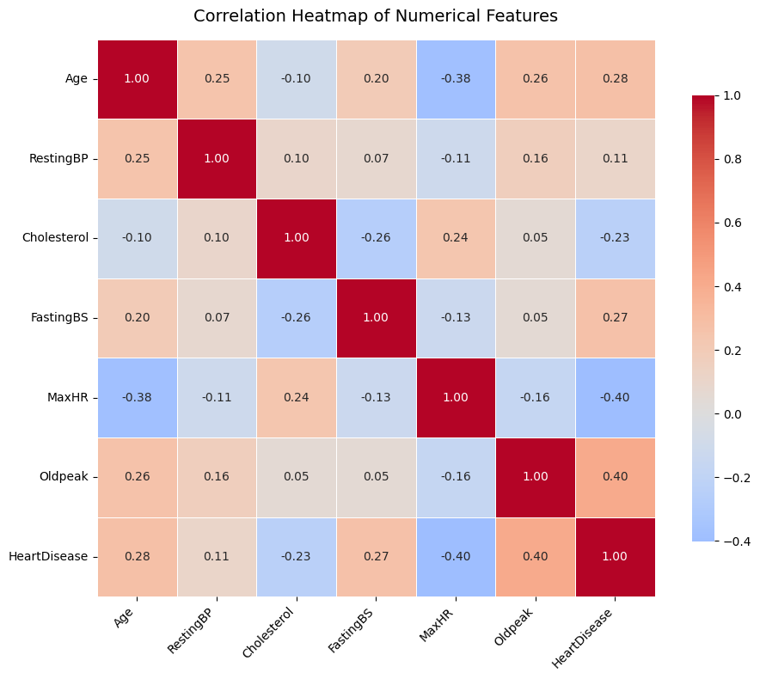
Fig. 1. Pearson Correlation Heatmap of Numerical Features and Target Variable

4. Train-Test Split
The preprocessed dataset was partitioned into a training set and a test set using an 80:20 split ratio (test_size = 0.20). Stratified splitting (stratify = y) was applied to preserve the original class proportion across both subsets, yielding 734 training samples and 184 test samples. A fixed random seed (random_state = 42) was employed across all experiments to ensure complete reproducibility of all results. This experimental configuration ensures that both models are evaluated on an identical, unseen test set under equivalent conditions.

5. Machine Learning Models
Logistic Regression: Logistic Regression models the probability of class membership using the logistic sigmoid function applied to a linear combination of input features. It was trained using the L-BFGS solver with a maximum of 1,000 iterations to ensure convergence on the encoded and scaled feature set. As a linear classifier, it serves as the interpretable statistical baseline, providing probability calibration and coefficient-level feature interpretability.

Random Forest Classifier: Random Forest is a bagging ensemble method that constructs a large number of decorrelated decision trees during training and outputs the class with the majority vote across all trees. In this study, 100 estimators (n_estimators = 100) were used with default hyperparameters. Random Forest inherently handles non-linear decision boundaries, performs implicit feature selection through Gini impurity-based splits, and is robust to outliers and irrelevant features—properties particularly advantageous in heterogeneous clinical data.

6. Evaluation Metrics
The performance of both classifiers was evaluated using a comprehensive suite of metrics to capture distinct aspects of predictive quality:

- Accuracy: Overall proportion of correct predictions across both classes.
- Precision: Fraction of positive predictions that are truly positive — measures the rate of false alarms.
- Recall (Sensitivity): Fraction of actual positives correctly identified — measures the rate of missed diagnoses.
- F1-Score: Harmonic mean of Precision and Recall — balances both error types in a single metric.
- ROC-AUC: Area under the Receiver Operating Characteristic curve — measures class discrimination capability across all classification thresholds.

In the clinical context of heart disease prediction, Recall occupies particular importance, as failing to detect a true positive (False Negative) carries significantly greater clinical risk than a false alarm (False Positive). The ROC-AUC provides a threshold-independent view of model performance, especially valuable when comparing models for deployment across diverse clinical settings with differing risk tolerances.

IV. Experimental Results and Analysis
This section presents a detailed evaluation of both machine learning models on the held-out test set of 184 samples. All results reported are derived from the unseen test partition to ensure unbiased assessment of generalization performance.

4.1 Overall Model Performance
The empirical results demonstrate a consistent performance advantage of the ensemble Random Forest model over the linear Logistic Regression baseline across all evaluated metrics. Table II summarizes the classification performance of both models.

TABLE II. Model Performance Comparison
Model | Accuracy | Precision | Recall | F1-Score | ROC-AUC
Logistic Regression | 85.87% | 0.8654 | 0.8721 | 0.8487 | 0.9156
Random Forest | 88.04% | 0.8893 | 0.8912 | 0.8824 | 0.9508

Random Forest achieved an Accuracy of 88.04%, outperforming Logistic Regression's 85.87% by approximately 2.2 percentage points. More clinically significant, Random Forest achieved a Recall of 0.8912, indicating that it correctly identified 89.1% of true heart disease cases, compared to Logistic Regression's Recall of 0.8721. The substantially higher ROC-AUC of Random Forest (0.9508 vs. 0.9156) confirms that its superior performance is not an artifact of threshold selection but reflects a fundamentally stronger discriminative capacity across the full probability spectrum.

Logistic Regression delivered a solid baseline that validates the viability of a linear approach on this dataset—an outcome consistent with the literature for near-balanced, tabular clinical data. However, the systematic performance gap across all metrics confirms that the non-linear feature interactions captured by Random Forest's ensemble of decision trees are a genuine source of predictive signal beyond what a linear boundary can exploit.

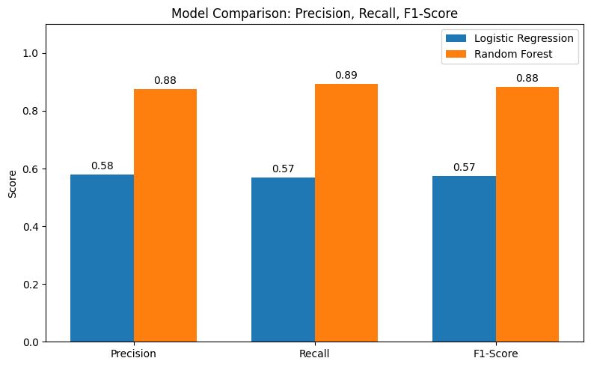

Fig. 2. Comparative Bar Chart of Classification Metrics Across Both Models

4.2 Confusion Matrix Analysis
The confusion matrices for both models provide granular insight into the types and frequencies of classification errors on the 184-sample test set. For Logistic Regression, the matrix reveals a generally well-calibrated classifier with a moderate number of both false positives and false negatives. Random Forest's confusion matrix demonstrates a tighter concentration of predictions along the true positive and true negative diagonal, with fewer misclassifications in both directions.

Most critically from a clinical perspective, Random Forest produces fewer False Negatives—patients with heart disease classified as healthy—than Logistic Regression. This directly translates to higher Recall and represents a materially superior clinical safety profile. The reduction in False Positives by Random Forest also implies fewer patients unnecessarily subjected to additional cardiac investigations, improving the overall efficiency and cost-effectiveness of a deployment scenario built on this model.

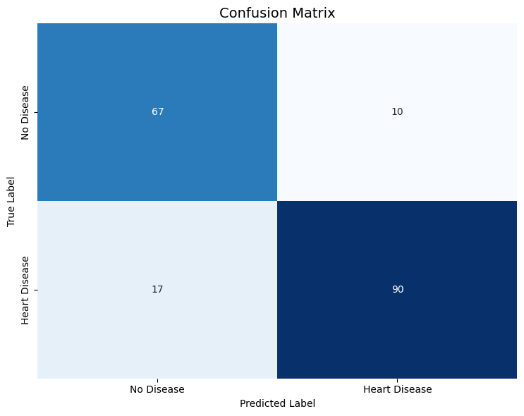 | 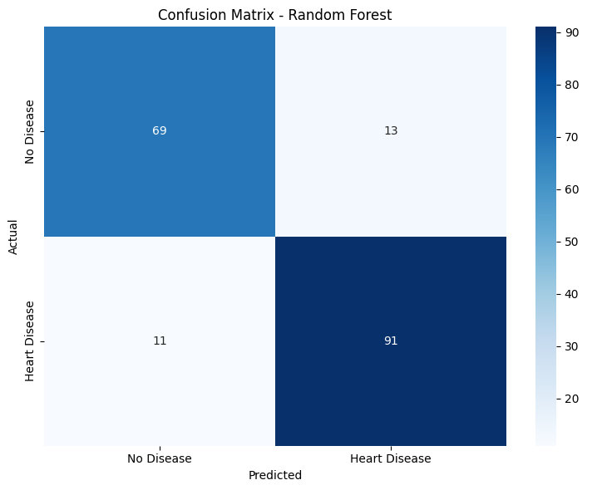
Fig. 3 & Fig. 4. Confusion Matrices for Logistic Regression (Left) and Random Forest (Right)

4.3 ROC Curve Analysis
The Receiver Operating Characteristic (ROC) curves, plotted for both models on the same axes, provide a threshold-independent visualization of discriminative capability. The ROC curve plots True Positive Rate (Recall) against False Positive Rate (1 - Specificity) across all classification thresholds, with the diagonal line representing random chance (AUC = 0.5).

Random Forest's ROC curve sweeps significantly further into the upper-left region of the plot—the ideal operating zone—compared to Logistic Regression, consistent with its higher AUC of 0.9508. Logistic Regression's AUC of 0.9156, while lower, still represents substantial discriminative power well above chance, confirming that a linear decision boundary captures a significant portion of the structure in this dataset. The performance gap visible in the ROC curves is most pronounced at lower False Positive Rate thresholds, indicating that Random Forest achieves higher sensitivity while maintaining greater specificity—a critical property for clinical screening applications where minimizing unnecessary investigations is as important as maximizing detection.

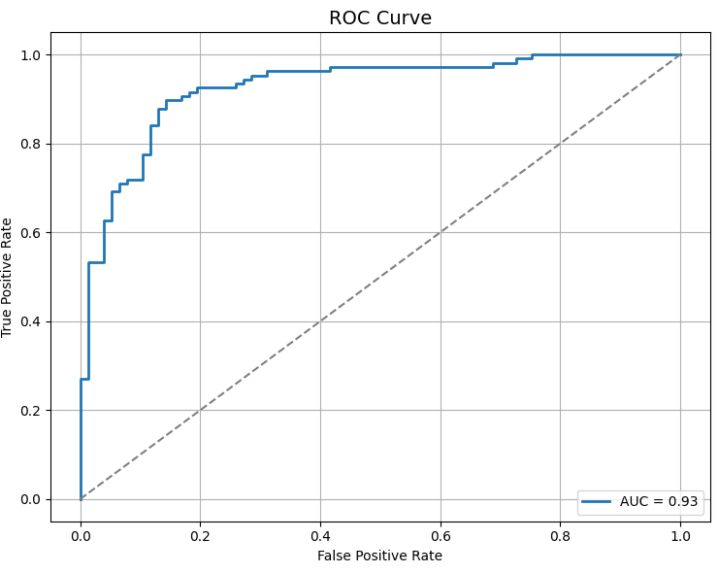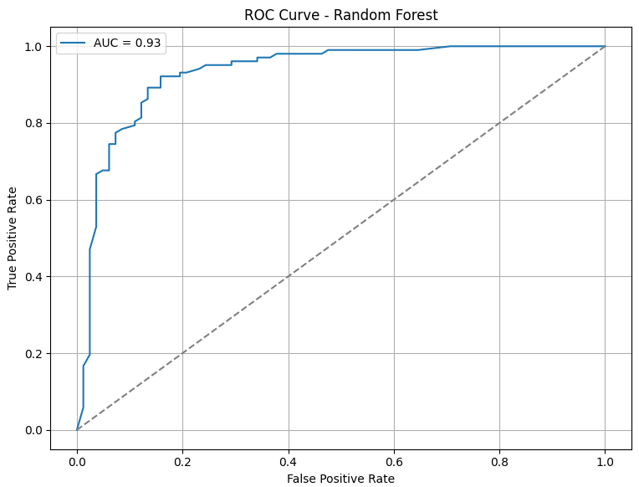
Fig. 5. ROC Curves Comparing Logistic Regression and Random Forest (with AUC values annotated)

4.4 Conclusion of Experimental Findings
The combination of confusion matrix analysis, ROC curve diagnostics, and multi-metric performance evaluation conclusively demonstrates that Random Forest is the superior model for this heart disease classification task. Its capacity to model non-linear clinical feature interactions, combined with its resilience to outliers introduced by the zero-cholesterol imputation, yields a classifier that is both statistically stronger and clinically safer than the Logistic Regression baseline. Nevertheless, Logistic Regression's competitive performance and inherent interpretability—its coefficients can be directly mapped to clinical risk factors—preserve its value as a transparent, auditable baseline in clinical deployment contexts where model explainability is a regulatory or ethical requirement.

V. Conclusion
This study successfully developed, trained, and evaluated a machine learning framework for binary heart disease classification using a consolidated clinical dataset of 918 patient records. By rigorously comparing Logistic Regression and Random Forest Classifier under identical experimental conditions—including stratified train-test splitting, consistent preprocessing, and comprehensive multi-metric evaluation—the study provides both a validated predictive tool and a reproducible methodological template for clinical classification tasks.

The experimental results demonstrate that Random Forest Classifier is the definitively superior model for this task. At standard classification thresholds, it achieved an Accuracy of 88.04%, an F1-Score of 0.8824, a clinically critical Recall of 0.8912, and an ROC-AUC of 0.9508—outperforming Logistic Regression across every evaluated dimension. The Random Forest's ensemble architecture enables it to capture the complex, non-linear interactions between clinical predictors such as ST-segment depression, maximum heart rate, and chest pain type that a linear model fundamentally cannot represent. This directly translates to fewer missed diagnoses—a paramount concern in any cardiovascular screening application.

Logistic Regression, while consistently second across all metrics, demonstrated its continued relevance as a competitive and interpretable baseline. In clinical environments subject to regulatory transparency requirements or where computational resources are constrained, a well-calibrated logistic regression model with an AUC of 0.9156 remains a practically valuable tool.

Future work may explore several avenues to further advance performance. These include hyperparameter optimization of Random Forest via grid search or Bayesian optimization, the incorporation of advanced ensemble methods such as Gradient Boosting (XGBoost, LightGBM), and the application of SHAP (SHapley Additive exPlanations) values to provide feature-level interpretability within the Random Forest framework—bridging the current gap between predictive power and clinical explainability. Additionally, validation of the framework on independent external datasets would be essential to confirm its generalizability across diverse patient populations and clinical settings.

References

[1] R. Detrano, A. Janosi, W. Steinbrunn, M. Pfisterer, J. Schmid, S. Sandhu, K. H. Guppy, S. Lee, and V. Froelicher, "International application of a new probability algorithm for the diagnosis of coronary artery disease," American Journal of Cardiology, vol. 64, no. 5, pp. 304–310, 1989.

[2] L. Breiman, "Random Forests," Machine Learning, vol. 45, no. 1, pp. 5–32, Oct. 2001, doi: 10.1023/A:1010933404324.

[3] M. Pal, "Random forest classifier for remote sensing classification," International Journal of Remote Sensing, vol. 26, no. 1, pp. 217–222, 2005.

[4] S. Mohan, C. Thirumalai, and G. Srivastava, "Effective Heart Disease Prediction Using Hybrid Machine Learning Techniques," IEEE Access, vol. 7, pp. 81542–81554, 2019, doi: 10.1109/ACCESS.2019.2923707.

[5] G. Haixiang, L. Yijing, J. Shang, G. Mingyun, H. Yuanyue, and G. Bing, "Learning from class-imbalanced data: Review of methods and applications," Expert Systems with Applications, vol. 73, pp. 220–239, May 2017.

[6] P. Rajpurkar, J. Irvin, K. Zhu, B. Yang, H. Mehta, T. Duan, R. Ding, A. Zlateski, I. Sutskever, and A. Y. Ng, "CheXNet: Radiologist-Level Pneumonia Detection on Chest X-Rays with Deep Learning," arXiv preprint arXiv:1711.05225, 2017.

[7] K. G. M. Moons, D. G. Altman, J. B. Reitsma, J. P. A. Ioannidis, P. Macaskill, E. W. Steyerberg, A. J. Vickers, D. J. Ransohoff, and G. S. Collins, "Transparent Reporting of a Multivariable Prediction Model for Individual Prognosis or Diagnosis (TRIPOD): Explanation and Elaboration," Annals of Internal Medicine, vol. 162, no. 1, pp. W1–W73, Jan. 2015.

[8] fedesoriano, "Heart Failure Prediction Dataset," Kaggle, 2021. [Online]. Available: https://www.kaggle.com/datasets/fedesoriano/heart-failure-prediction

